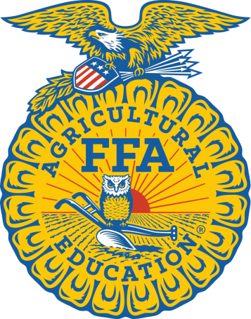

FFA makes a positive difference in the lives of students by developing their potential for ***premier leadership, personal growth and career success*** through agricultural education.

Agricultural education prepares students for successful careers and a lifetime of informed choices in the global agriculture, food, fiber and natural resources systems.

By joining FFA and experiencing the benefits of the organization, student members are creating their own success stories across the United

States, like tens of thousands of members who have come before them. 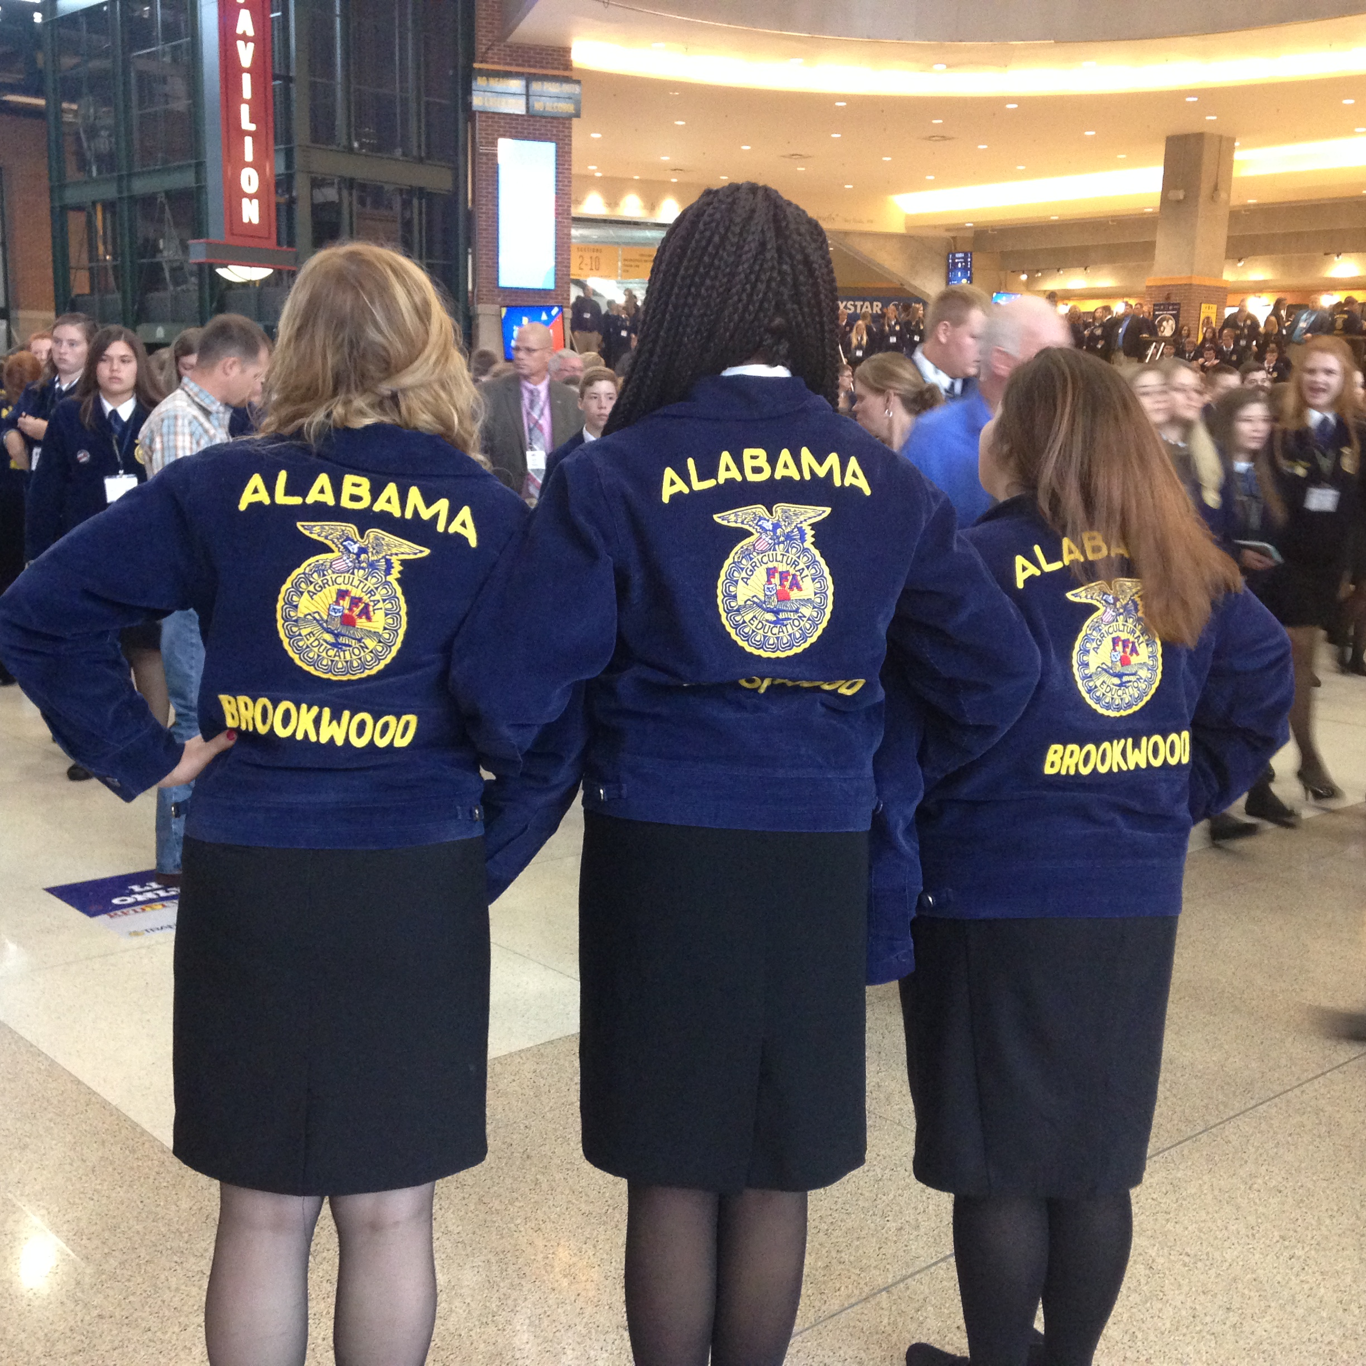

**SO HOW DO YOU JOIN Brookwood FFA?**

**1st---ENROLL in an agricultural science course elective.**

***9th grade-  
 Agriscience (1 credit)***

***10-12th grade-   
Agriscience (1 credit)  
Landscape Design and Management (1 credit)  
Horticulture (1 credit)  
Fish and Wildlife (1 credit)  
Floral Design and Interiorscaping (1 credit)***

**2nd---JOIN FFA membership it is FREE to Brookwood Agriculture students!**

**3rd---Stay active by participating in SAE’s, CDE’s and/or Leadership activities throughout the year**

**4th---HAVE FUN! EARN AWARDS, SCHOLARSHIPS, Join National CTE, etc.**

[](https://www.google.com/url?sa=i&rct=j&q=&esrc=s&source=images&cd=&ved=0ahUKEwicnYmJl8jVAhVERyYKHQZYDwgQjRwIBw&url=https://www.linkedin.com/pulse/what-you-waiting-exactly-alan-goldstein&psig=AFQjCNHTyaOLYIfjnt2H2QETDHsjlu_oGQ&ust=1502300322131261)

**Brookwood FFA /Ag. Dept.**

**Brookwood FFA /Ag. Dept.**

**12250 George Richmond Pkwy.  
Brookwood, AL 35444  
The BWHS Ag. Dept. does not discriminate on the basis of race, color, national origin, sex, disability, or age in its programs and activities and provides equal access to the Boy Scouts and other designated youth groups.**

***Welcome to BWHS FFA and Agriculture Department,***

**Ag Advisor:**

Mrs. Jennifer Crutchfield email: jcrutchfield@tcss.net

**FFA Officers/Leadership Team:**Meets on Friday during Advisory.  
**FFA Meetings and Trips:**FFA Meetings once a month you must join FFA to attend all FFA meetings and field trips . FFA meeting every second Thursday of the month.

**FFA State Convention/FFA National Convention:**FFA members can attend Alabama State Convention in Montgomery, AL the first week of June. FFA members can attend Alabama National FFA Convention in Indianapolis in October.

**WHAT IS FFA?**

FFA is a dynamic and growing youth organization, nearly half-a-million student members strong, based in agricultural science education. The National FFA is ***successfully changing lives and preparing students for leadership, personal growth and career success***. These lessons, skills, friendships and experiences shape our members and the benefits remain for their entire lives. Members ***participate in a wide range of agricultural science education activities, leading to the possibility of more than 300 professional career opportunities***. The continued success of our student members remains the primary mission of FFA.

**OUR Brookwood FFA MISSION**

The Brookwood FFA chapter is dedicated to making a change in the lives of its members through agricultural education and FFA membership, by demonstrating good sportsmanship, promoting personal growth, building leadership skills to impact others and encourage each other to reach outside their comfort zone.

**WHO CAN BE INVOLVED?**

[](https://www.google.com/url?sa=i&rct=j&q=&esrc=s&source=images&cd=&cad=rja&uact=8&ved=0ahUKEwj4gpHujcjVAhXLSCYKHeZcC7YQjRwIBw&url=https://www.pinterest.com/lindseyscarlett/ffa/&psig=AFQjCNEP-nUYjZuVFOiZrLRPqsqEYlCkLg&ust=1502297880235552)Any student in grades 9-12 who is ***enrolled in an agriculture course*** at a public school is eligible to join FFA. Students from ***all socio-economic, racial and geographic backgrounds*** make up the organization’s impressive and diverse base. More than 70 percent of our members are from ***rural non-farm, urban and suburban areas*** and the remaining 30 percent come from more traditional farming communities.

**WHY AGRICULTURAL SCIENCE EDUCATION AND FFA?**

Agricultural science education and FFA help students ***discover their passion in life, develop their strengths, introduce them to new experiences and achieve success***.

The agricultural science education program is ***more than "just a class"*** – it is an integrated approach to education. This integrated approach provides students with academic instruction, hands-on experience and the development of critical life skills necessary for career success.

The academic instruction is similar to traditional classes with the ***setting in the classroom, greenhouse, agriscience laboratory, agricultural mechanics shop or other agriculture centers*** where students learn from the agriculture teacher. However, unlike traditional classes, the agricultural science classes are like a beehive of activity with students discovering how much fun learning can be by doing.

**SUPERVISED AGRICULTURAL EXPERIENCES**

[](https://www.google.com/url?sa=i&rct=j&q=&esrc=s&source=images&cd=&cad=rja&uact=8&ved=0ahUKEwjQicTyksjVAhUK7yYKHZWLA4gQjRwIBw&url=https://www.texasffa.org/sae&psig=AFQjCNHnv40ZC3-UiAe1FWfow-Yp16jSOg&ust=1502299229291432)Supervised Agricultural Experiences (SAEs) give students a well-rounded view of career opportunities by exposing members to ***real world hands-on agricultural experiences conducted outside of the classroom***. An SAE is a ***work experience*** that is created and carried out by the student. This part of the integrated model gives students a chance to explore the career areas that interest them. The SAE ***must relate to the field of agriculture but can be as diverse as food science to wildlife management to experiments in animal nutrition***. Students are encouraged to be entrepreneurs by starting a business or gain valuable career experience by working for an established company.

**CAREER DEVELOPMENT EVENTS**

Career Development Events build on what is learned in agricultural classes and encourage members to put their knowledge into practice. These events are designed to help a member ***prepare for a career in agriculture*** by testing and challenging the student's technical, leadership, interpersonal and teamwork skills as well as their knowledge of the subject matter. CDEs answer the question, ***"When will I use this knowledge in the real world?"***

Many CDEs are qualifying events for the National FFA CDE competition and/or offer scholarship opportunities. 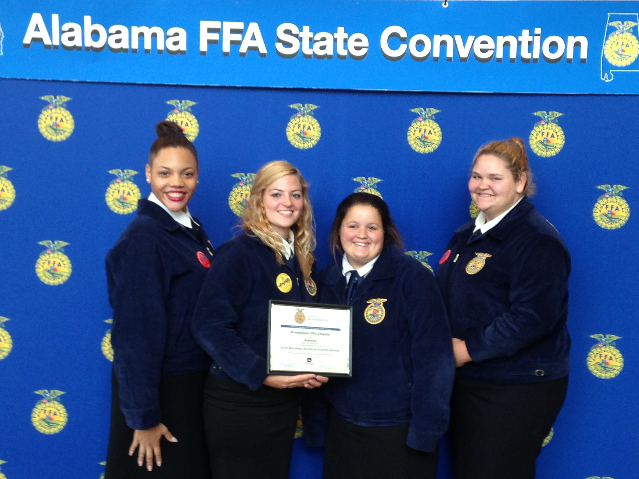

**LEADERSHIP EVENTS**

Leadership Events focus on creating situations for members to ***demonstrate their abilities in public speaking, decision making, communication and their knowledge of agriculture and the FFA organization***. Students have opportunities to attend various events and trips throughout the year that build their leadership skills such as Joint Leadership Development Conference, Career and Technical Safety Day, Reality Check, World of Work and much more.